Managing Quality

# Directions

Complete the simulation found on the Assignment Manager page on the Pearson site and complete the questions below.

# Questions

1. What were the first initial investments and why?
2. What were the following results?
   1. Total profits
   2. Star rating
   3. Average failure rate
   4. Cost of quality
3. How was it decided whether to invest in the cheaper or the more expensive option?
4. What is the difference between the cost of an internal and external failure expense?
5. Were the goals reached for the simulation? If not, how could it have been improved? If yes, then what was done that led to the success?

# Overview

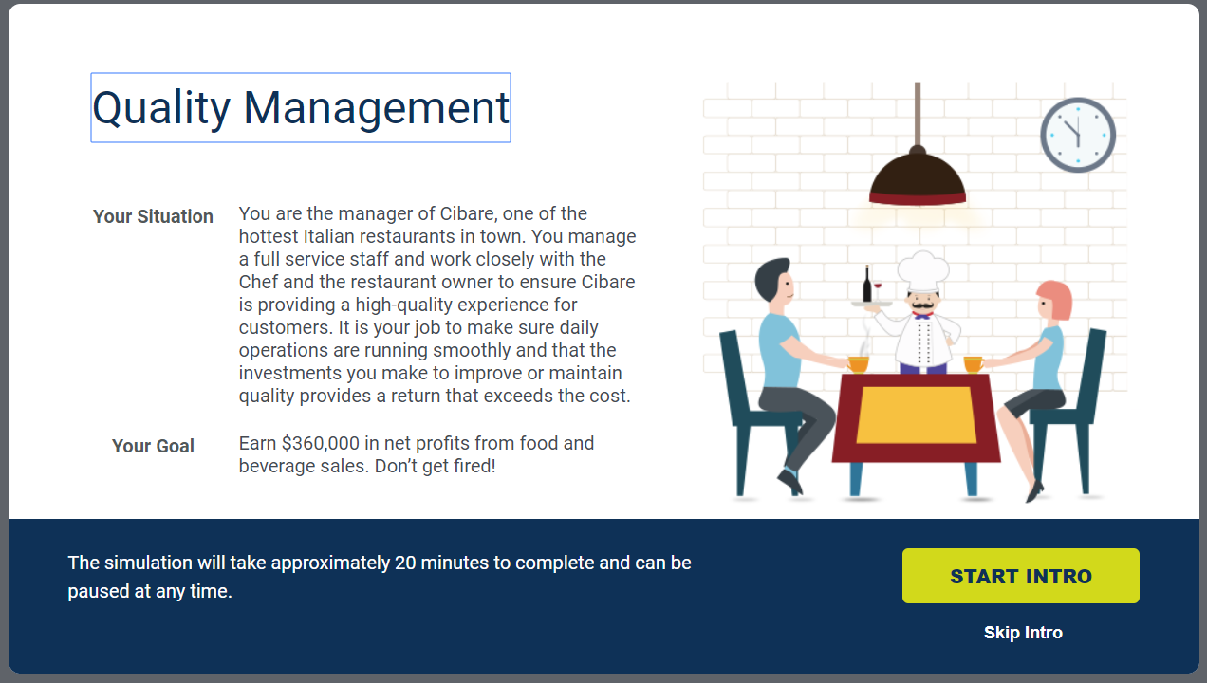

## Dashboard – Final

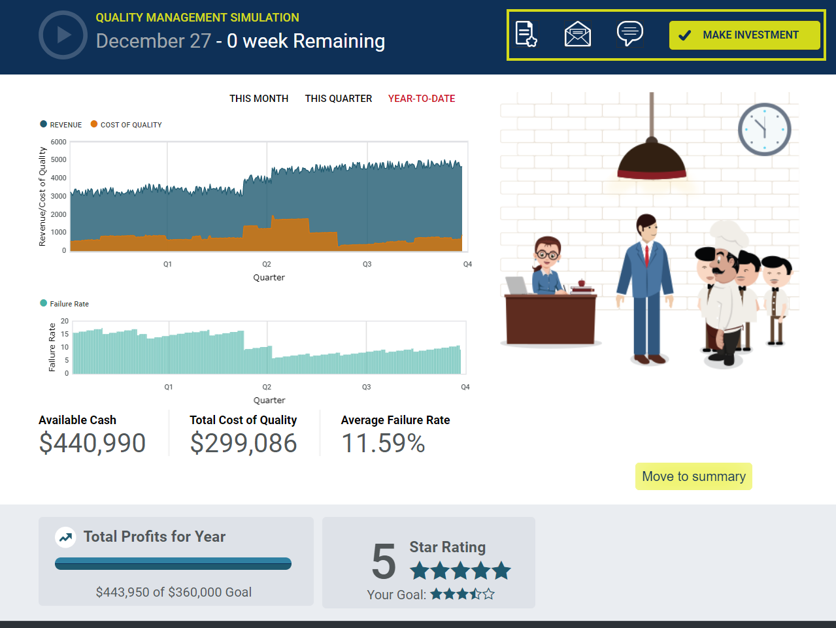

## Summary – General Feedback

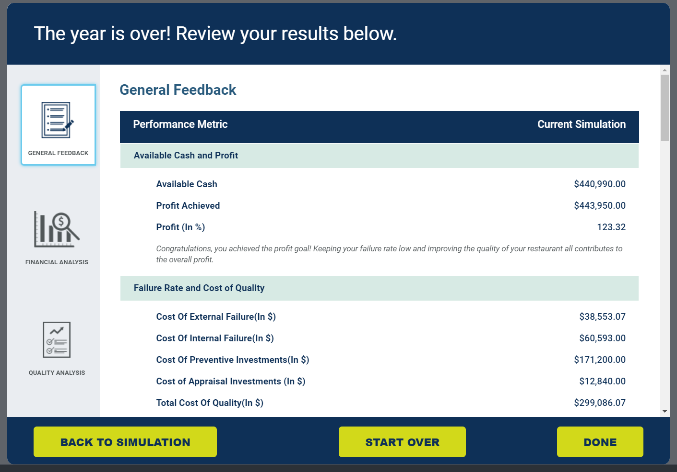

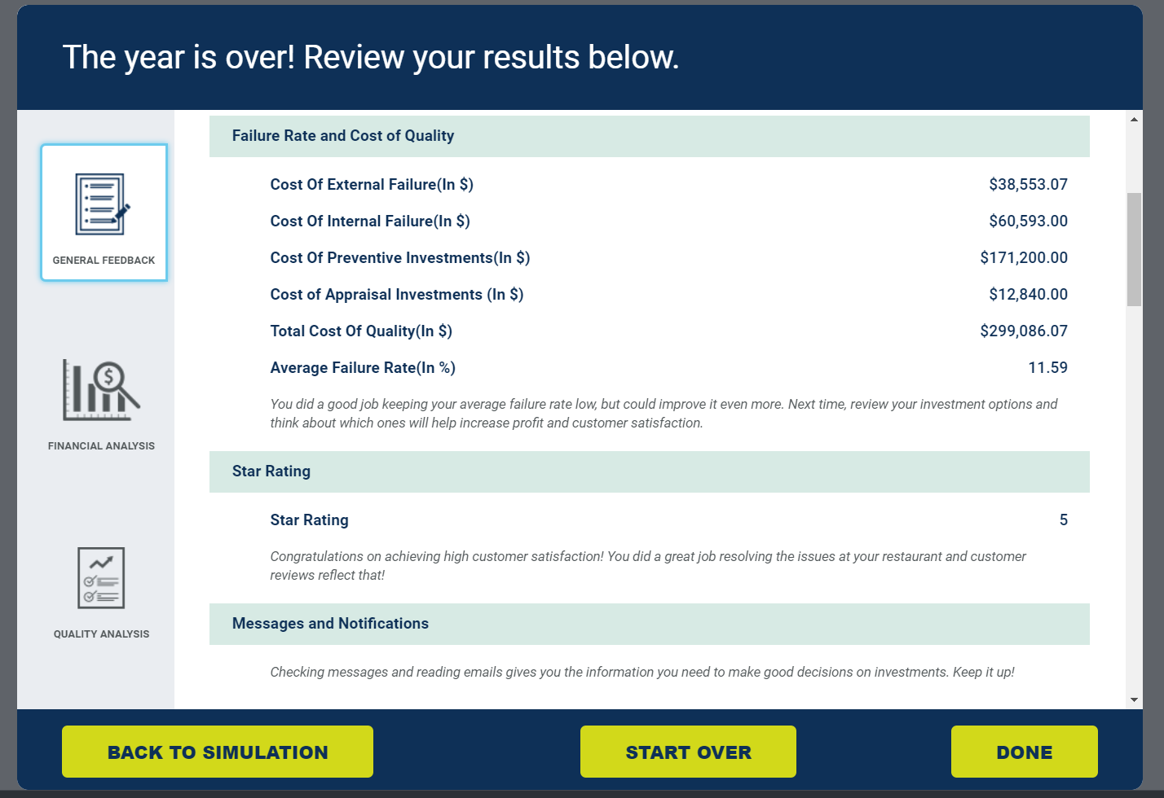



## Summary ­­­– Financial Analysis­­

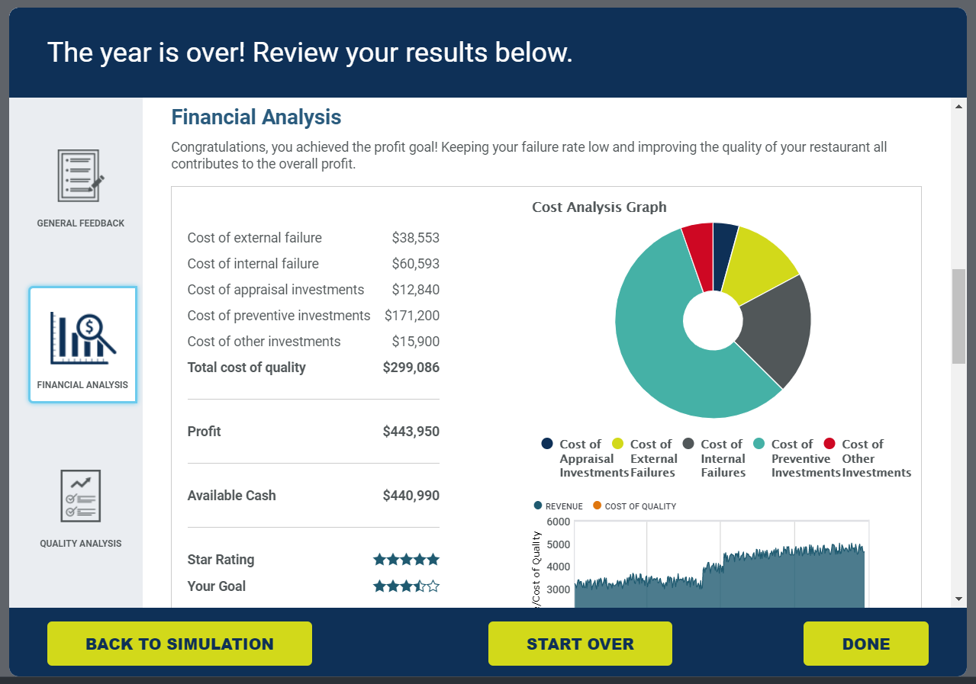

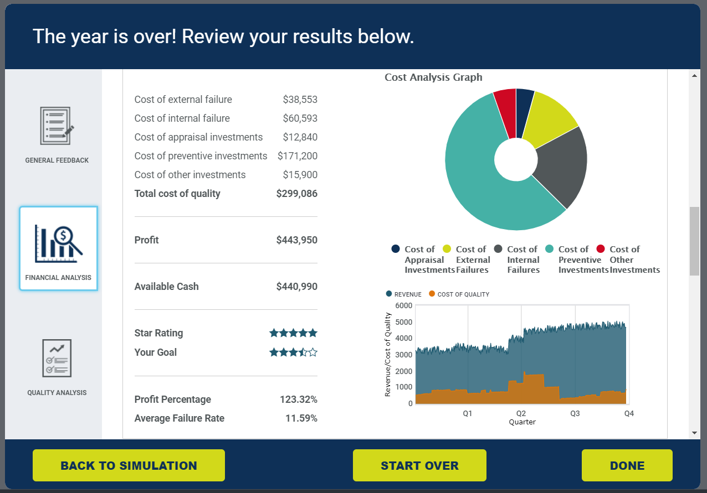

## Summary – Quality Analysis

